TASK 4
Data Science Tool Mastery Project
Hands-on proficiency with the core Python data stack
Data Science Internship Report
Submitted by: [Your Full Name]
November 2026

1. Introduction
Learning a tool is different from knowing it. For this task I picked the tools that show up in almost every data science job description and worked through a concrete exercise for each, aiming not just to make the code run but to understand why one approach is better than another. My specialisation focus is data analysis with an entry into machine learning, so the stack is: NumPy, pandas, SQL (via SQLite), Matplotlib and Seaborn, scikit-learn, Jupyter and Git.
All code is in the repository as scripts/task4_tool_mastery.py. The timings below were measured on a standard cloud machine, so absolute numbers will differ on other hardware, but the relative gaps are what matters.

2. NumPy: vectorisation
NumPy stores numbers in compact arrays and runs operations in optimised compiled code. To see how much that matters, I applied the same arithmetic (x * 2 + 1) to one million numbers using a plain Python list comprehension and using a NumPy array.
Approach | Time | Relative
Python list comprehension | 0.0652 s | 1×
NumPy vectorised | 0.00095 s | about 69× faster

A sum-of-squares calculation was even more lopsided: np.dot(a, a) ran roughly 115× faster than a Python loop. The takeaway I keep applying: if I am writing a for loop over numbers, there is probably a vectorised way to do it.

3. pandas: idiomatic data manipulation
I tested three ways to compute price per carat on 20,000 rows of the diamonds dataset:
Method | Time | Comment
iterrows() loop | 0.734 s | Easiest to read, slowest by far
apply(axis=1) | 0.214 s | Better, but still row by row
Vectorised column division | 0.00014 s | One line, thousands of times faster

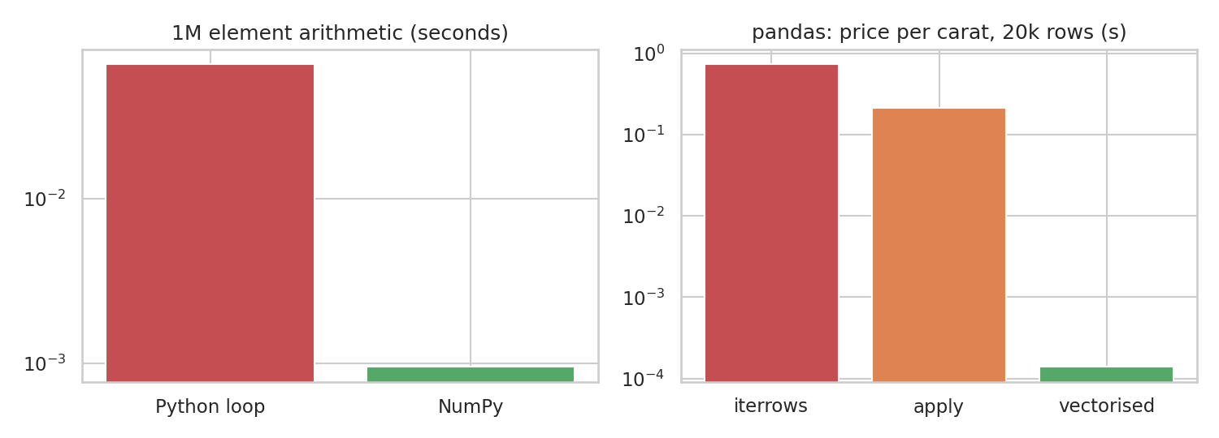
Figure 1. Log-scale timings: loops versus vectorised operations.
Beyond speed, I practised the pandas skills I use constantly: boolean filtering, groupby with named aggregations, pivot_table, merging, handling dates with pd.to_datetime, and converting columns to the category dtype. Method chaining (for example df.query(...).assign(...).groupby(...)) made my scripts much easier to read from top to bottom.

4. SQL alongside pandas
Data often lives in a database, so I loaded the same 20,000 rows into an in-memory SQLite database and answered one question both ways: average price and count by diamond cut.
SELECT cut, COUNT(*) AS n, ROUND(AVG(price), 1) AS avg_price
FROM diamonds
GROUP BY cut
ORDER BY avg_price DESC;
The SQL result and the pandas groupby result matched exactly (verified in code: True). Premium cut came out highest at about $4744.7, while Ideal was around $4450.5. This looks backwards at first, but this is probably because ideal-cut stones tend to be smaller, so the cut label gets mixed up with size (I confirm this effect on the full dataset in the capstone). Knowing both SQL and pandas means I can move between a warehouse and a notebook without friction.

5. Matplotlib and Seaborn: communicating with charts
I used Matplotlib for control (titles, log scales, annotations, subplots) and Seaborn for quick statistical plots (histograms with density curves, box plots, heatmaps). My working rules for charts: one message per chart, label axes and units, avoid decoration that adds nothing, and use a log scale when values span several orders of magnitude, as in Figure 1. The charts in the other tasks of this internship were all produced this way.

6. scikit-learn: pipelines instead of loose steps
The most valuable thing I learned in scikit-learn was the Pipeline with a ColumnTransformer. Instead of imputing, scaling and encoding by hand (and risking leaking test data into training), I wrapped everything in one object that is fitted only on the training data. I tested it on the Titanic dataset to predict survival from age, fare, family, class, sex and port.
numeric = Pipeline([("impute", SimpleImputer(strategy="median")), ("scale", StandardScaler())])
categorical = Pipeline([("impute", SimpleImputer(strategy="most_frequent")), ("onehot", OneHotEncoder(handle_unknown="ignore"))])
pre = ColumnTransformer([("num", numeric, num_cols), ("cat", categorical, cat_cols)])
model = Pipeline([("pre", pre), ("clf", LogisticRegression(max_iter=1000))])
Model | 5-fold CV accuracy | Test accuracy | Test F1
Majority-class baseline | - | 0.615 | -
Logistic Regression | 0.796 | 0.804 | 0.724
Random Forest | 0.789 | 0.81 | 0.738

Both models beat the 0.615 baseline by about 19 percentage points, but they are nearly tied with each other: the 0.01 gap in test accuracy is well within what I would expect from the small test set (179 passengers). I read this as "the simpler, more explainable model is good enough here", not as evidence that the random forest is better. The random forest's confusion matrix shows 97 true negatives, 13 false positives, 21 false negatives and 48 true positives.

7. Jupyter and Git: the supporting cast
- Jupyter for exploration, because I can see each step’s output immediately. Once an analysis settled, I moved the logic into scripts so it could run top to bottom without hidden state.
- Git and GitHub for versioning. Each task lives in its own script with its own outputs, committed with short descriptive messages.
- requirements.txt to pin library versions and make the environment reproducible.

8. Portfolio pieces produced
Project | Tools shown | Repository file
Statistics fundamentals demo | pandas, SciPy, Matplotlib | task1_fundamentals.py
Restaurant tips lab | pandas, NumPy, Seaborn | task2_lab_tips.py
Titanic data cleaning and EDA | pandas, SciPy, Seaborn | task3_titanic_eda.py
Tool benchmarks and ML pipeline | NumPy, pandas, SQL, scikit-learn | task4_tool_mastery.py
NYC taxi business analytics | pandas, Matplotlib | task5_taxi_analytics.py
Diamond price prediction capstone | scikit-learn, pandas, Seaborn | task6_capstone_diamonds.py

9. Reflection
The pattern across every tool was the same: the first way that works is rarely the best way. Vectorising instead of looping, wrapping preprocessing in a pipeline instead of doing it manually, and checking SQL against pandas all produced results that were faster, safer or easier to trust. Going forward I want to go deeper into SQL window functions, model tuning and cross-validation strategy, and into dashboards for sharing results with non-technical audiences.

